

Tiankuo Server

I980-G10

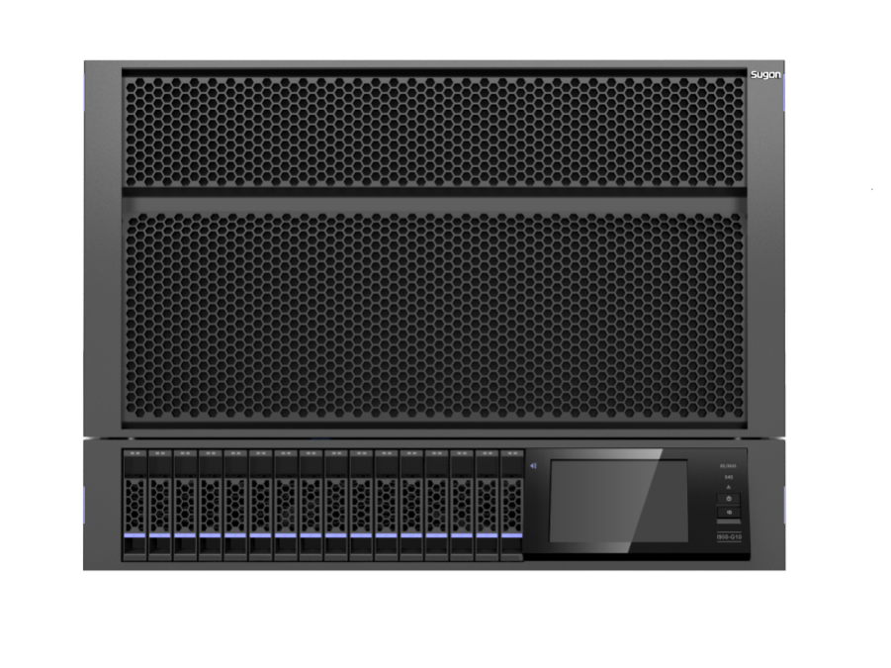

|  |
| --- |
| Sugon I980-G10 is a newly introduced 8-way server which is independently developed by Sugon, it supports Intel® Xeon® E7-8800 V2 series of processors. Leading architecture design is used, maximum 120 processor cores and 8TB memory can be configured, and the product can provide excellent computing and expansion capabilities. Owning more than 60 RAS features, I980-G10’s reliability is comparable to minicomputers, thus to ensure the stable and reliable operation of critical business. I980-G10 has outstanding performance and is an ideal choice for large databases, commercial intelligent analysis, EPR and other critical business. |

|  |
| --- |
| **Overview** |
| High performance  Supporting maximum 8 Intel Xeon E7-8800 v2 series of processors, compared to the previous products, I980-G10’s computing performance is improved by 2 times, the memory capacity is improved by 3 times and the I/O bandwidth is improved by 4 times.  High reliability  All critical components adopt redundant design to reduce the downtime probability caused by a single component failure, and the product is designed with more than 60 RAS features to realize the whole-process data protection and error correction from the operating system to the hardware FW and then to the chips. Thus it can ensure the integrity, consistency of data and improve the machine reliability.  High manageability  The intelligent BMC management independently developed by Sugon can realize overall device management, monitoring, configuration, faults positioning and analysis. With the touchable LCD monitoring screen, the product can realize overall monitoring on the machine’s health status. CPU, memory, hard disk, PCI-E external card, fans, power supply and network card are all configured with LED lights, thus to know the health status of the machine easily.  Ultra high expansibility to protect customer investments  Maximum 8TB memory, 16(+2) storage capability and 16 PCI-E  Complete modularization design  The entire system is composed of 7 modules, including the computing module, storage module, IOE module, fans module, Gigabit module and monitoring module. It completely gets rid of the traditional wiring methods, realizes convenient online maintenance removal and installation and guarantees the business not to be interrupted. |

Features:

* High performance
* High reliability
* High manageability
* Ultra high expansibility
* Complete modularization design

**Technical features**

**Functional features** **Advantages**

More than 60 RAS features, reliability matches with minicomputers

The product supports memory failure warning, memory mirroring, memory hot standby, ECC, double device data correction DDDC, DDDC+1 and a variety of memory RAS technologies; Sugon hardware partition technology support is divided into 2 4-way servers, which can be configured flexibly to protect investments; all of the critical components, such as the storage module, fans module, power supply module, adopting redundant architecture design, the system is free from single-point failures, and thus the unit reliability is significantly improved. The product uses an on-demand cooling partition provision design, supporting to work continuously in high-temperature environments.

Complete modularization design

The system is composed of 7 modules, including the computing module, storage module, IOE module, fans module, power supply module, Ten-gigabit module and the monitoring module, it abandons the complex connected cables in traditional servers, and the unit reliability is greatly improved; all critical business modules are designed with hot swap function, and failure components can be replaced online, thus to ensure the continuity of business, simplify the operation process, shorten device deployment cycles and maintenance cycles. And no impact will be created to applications and operations of users.

Ultra powerful BMC monitoring and management function

Starry optical channel

All modules and critical components inside modules are equipped with LED lights; CPU, memory, hard disk, PCI-E external card, fans, power supply and network card are all configured with LED lights to show the overall health status and realize convenient management, monitoring, configuration and rapid failure positioning against the device.

With unit configuration information, BIOS and FW version information can be displayed, monitoring all component information, including CPU, memory, hard disk, power supply, fans, board-mounted network card, external card and other information; detailed faults warning contents, including faults type, detailed faults description, faulty components positioning; remote upgrading of BIOS, BMC FW and other remote management functions；supporting virtual media, remote switching and remote KVM functions, etc.

Offline optional diagnosis

Monitoring the overall operation state of the machine, it intuitively observes the monitoring information about all components; all BMC failure warning functions can be realized by failure alarm; detecting the health status of the unit more intuitively and rapidly finding out faults positioning; common setting functions, realize effective management on units switching, BMC IP, partition mode and user information.

Touch LCD monitoring screen

Industry-leading offline optional diagnostic technology：even in an offline state, the computing module can normally light the LED indicator in the starry optional channel, positioning the faulty components easily and accurately, thus to significantly improve the online maintenance capability to ensure the continuity of business.

**Technical specifications**

|  |  |
| --- | --- |
| Host performance | |
| Processor | Maximum 8 Intel Xeon E7-8800 V2 series of processor can be supported |
| Memory properties | Supporting DDR3 ECC Registered memory |
| Slots and capacity | 128 memory slots, each CPU board can support maximum 2CPU，32DIMM slots. |
| Hard disk controller | SAS or SAS RAID cards are optional |
| Hard disk | Maximum 16 2.5 " SATA, SAS, SSD hard disks can be supported  Double partition mode: each partition can support 2 built-in mSATA disks.  Single partition mode: maximum 2 built-in mSATA disks can be supported.  For machine, 1 or 2 RAID cards can be selected.  When 1 SAS/SAS RAID card is selected, maximum 8 disks can be supported, with 1 disk back board, 2 Minisas cables and 8 hard disk trays.  When 2 SAS/SAS RAID cards are selected: 2 disk backboards, 4 Minisas cables and 16 hard disk trays. |
| Display system | Integrated AST 2300 graphics controller (video memory:16MB) |
| Network | Integrated intel I350 4-port Gigabit network card  1or 2 intel82599 SFP+double-port Ten-gigabit module (PCI0E slot will not be occupied) |
| Expansion properties |  |
| Expansion slots | 16 PCI-E3.0x8 slots (supports half-height, half-length card) or 4 PCI-E3.0 x16 modules (supports full-height, full-length card)  When it is a single partition, (8-way server or a single 4-way server), maximum 8 PCI-E cards can be externally inserted.  When it is a double partition, (double 4-way server), each unit can externally insert 8 PCI-E cards.  Maximum 4GPU cards can be supported. |
| Touchable LCD monitoring screen | Standard configuration |
| Taper | Optional |
| SATA CD-ROM | Standard configuration |
| External interface of the front panel | One front VGA interface and two front USB interfaces. |
| External interface of the rear panel | Optional number of required management module is 1or 2  When it is a single 8-way or a single 4-way server, one management module shall be used.  When it is a double 4-way servers, 2 management modules shall be used.  Specification for the management panel:  1 VGA interface  4 USB2.0 interfaces  4 RJ45 internet accesses（intel I350 internet card chip）  1 COM interface  1 fiber management internet access |
| Power supply | Supports 4 power supply modules (maximum), each module is 2000W, champion conversion efficiency: 94%  Based on different loads, redundant N+N or N+1 can be realized.  Supports high-voltage DC. |
| Cooling fans | eight 8038 system fans  Maximum 10000rpm，Maximum power consumption:26W |
| Rake | 8U racket rake |
| Rake dimensions |  |
| Rake dimensions | 799.08mm(L) x 483.14mm(W) x 352.0mm(H) |
| Full-configuration  gross weight | 97.8KG full configuration (excluding package) |
| Compatibility of the operating system |  |
| Operating system | Windows Server 2008 R2 64bit  Red hat Enterprise Linux 6.2 64bit  SuSE Linux 11Enterprise Server sp2 64bit, etc.  Compatibility of the operating system is largely associated to the system configuration, for more information, please consult sales representative of Sugon or Sugon customer hot line. |
| Environment adaptability |  |
| Temperature range | For work: 10℃～35℃(50℉～95℉)  For storage: -40℃～55℃(-40℉～131℉) |
| Relative humidity range | Maximum relative humidity for work:90% RH（40℃）  For work:35％～80％ RH  For storage:20％～93％ RH |
| Vibration | Frequency: 5Hz～150Hz; acceleration≤20m/s2 , amplitude:0.15mm |
| Impact | Peak acceleration: 150m/s2 ～300m/s2 ; duration ≤11ms |
| Collision | Peak acceleration: 100m/s2 ～150m/s2 times: not more than 100 times |

Note:

1. All rated temperature values refer to the sea level. When the attitude rises 300 meters, the temperature will reduce 1℃, maximum attitude height:3000m. Avoid direct sunlight.
2. Limit of working attitude: 3000m. Limit of non-working attitude: 9000m.
3. The maximum storage humidity of 93％ is based on the maximum temperature of 40℃. The maximum storage height is corresponding to the minimum pressure of 70kPa.
4. Maximum humidity gradient under non-working conditions:10% RH per minute.

Note: the above table shall only be used for reference. For specific configurations, please contact with our sales representatives. Sugon reserves the right to modify the above configurations without additional notification in advanced.

|  |
| --- |
| **For more information:**  Please visit official Sugon website: www. Sugon.com or dial the customer service hot line:400-810-0466  You can also contact Sugon branches distributed throughout the country. For contact information, please log in the official website of Sugon.  Sugon reserves the right modifying the product specifications or other product information (including, but not limited to weights, appearance, dimensions or other physical elements) without any further notification.  Any alternation to information involved in the document caused by products upgrading or other causes, no additional notification will be provided. All product graphics involved in the document shall be subjected to the physical products. |